Toan Nguyen - 100979753

galaxy defender documentation

Table of Contents

I. GAME DESCRIPTION 2

II. CONTROL DESCRIPTION 2

III. INTERFACE SKETCH 2

a. Start Scene 2

b. Main Scene 2

c. End Scene 3

IV. SCREEN DESCRIPTIONS 3

a. Start Scene 3

b. Main Scene 4

c. End Scene 4

V. ENEMIES 5

VI. SCORING 5

VII. SOUND INDEX 5

a. Explosion Sound Effect 5

b. Collecting Coin Sound Effect 5

c. Background Sound 5

VIII. ART/MULTIMEDIA INDEX 5

a. Player Spaceship 5

b. Meteors 6

c. Coins 6

d. Health 6

e. Explosion 6

f. Bullet 6

g. Background 6

# **GAME DESCRIPTION**

This is a 2D space shooter game with 3 scenes – Start, Main and Win. A player will control a spaceship to destroy or avoid meteors. A player will get points when destroying meteors or collecting coins. 5 points for collecting each coin and 1 point for each meteor. If a spaceship collides with a meteor, a player loses 1 life. After losing 3 lives, a player will lose.

# **CONTROL DESCRIPTION**

Use W, A, S, D to move up, left, down, right

Use Spacebar to shoot

# **INTERFACE SKETCH**

## **Start Scene**

Title

Start Button

## **Main Scene**

Coin Image

Heart Image

Spaceship

Score

Lives

## **End Scene**

High Score

Game Over

Play Again Button

# **SCREEN DESCRIPTIONS**

## **Start Scene**

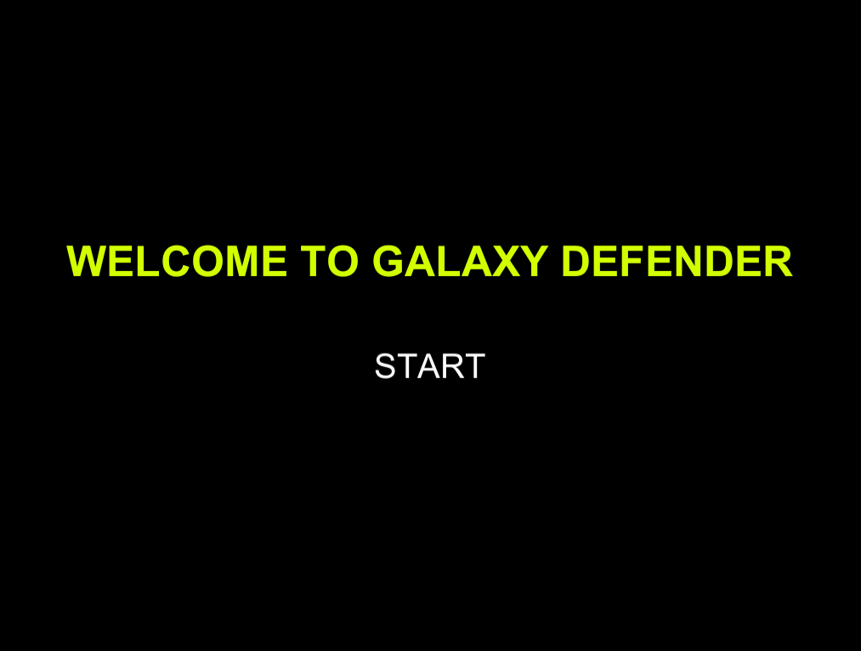

## **Main Scene**

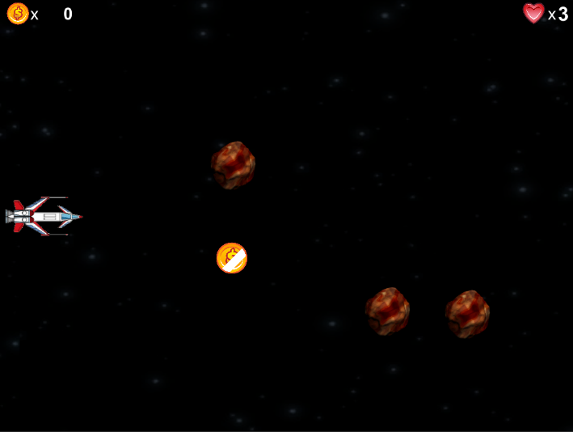 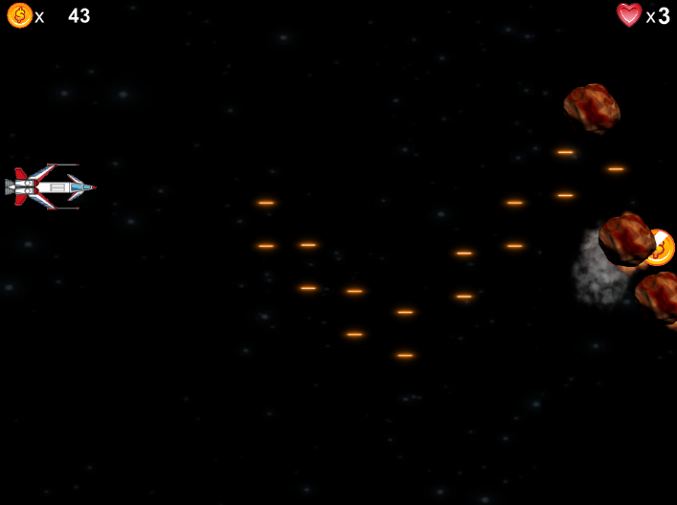

## **End Scene**

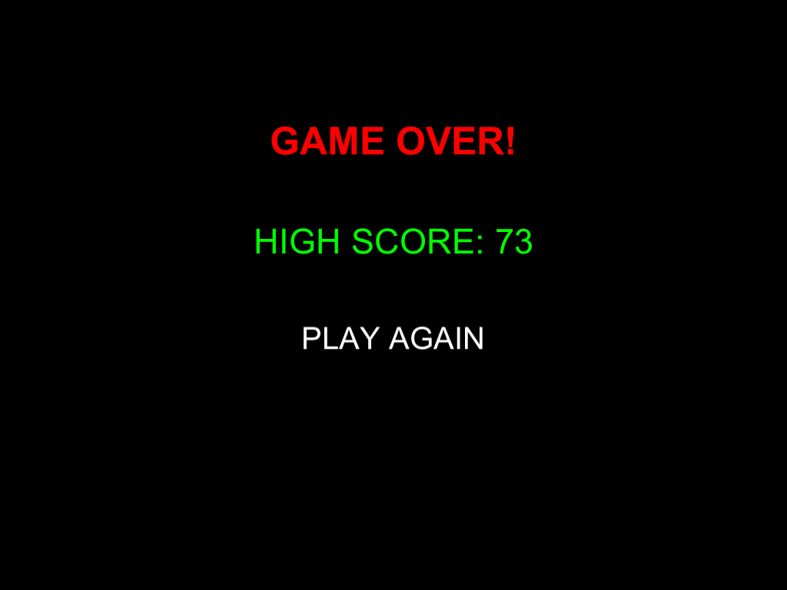

# **ENEMIES**

Enemies are meteors. They are placed outside of the screen. Meteors float into screen randomly up-left or down-left with random speeds. If meteors hit the screen boundary, those will respawn automatically.

# **SCORING**

A player will get points when destroying meteors or collecting coins. 5 points for collecting each coin and 1 point for each meteor.

# **SOUND INDEX**

## **Explosion Sound Effect**



## **Collecting Coin Sound Effect**



## **Background Sound**



# **ART/MULTIMEDIA INDEX**

## **Player Spaceship**

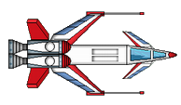

## **Meteors**



## **Coins**



## **Health**



## **Explosion**



## **Bullet**



## **Background**

